Vilvesh Srinivasan

# COSC-2436

A5 interactions

**Image 1**

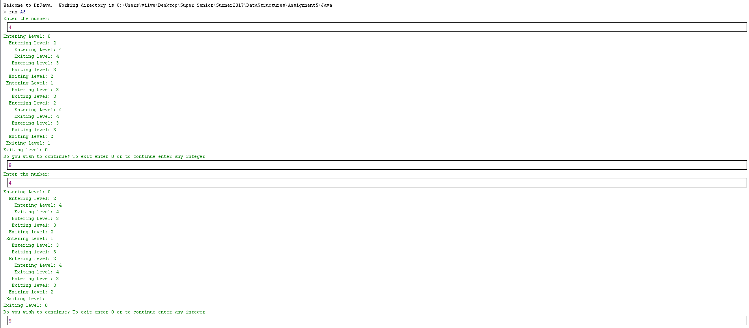

**Image 2**

